**Lab. Tutorial Module 4**

**In [11]**

from sklearn.datasets.samples_generator import make_circles

X, y = make_circles(100, factor=.1, noise=.1)

clf = SVC(kernel='linear').fit(X, y)

plt.scatter(X[:, 0], X[:, 1], c=y, s=50, cmap='autumn')

plot_svc_decision_function(clf, plot_support=False);

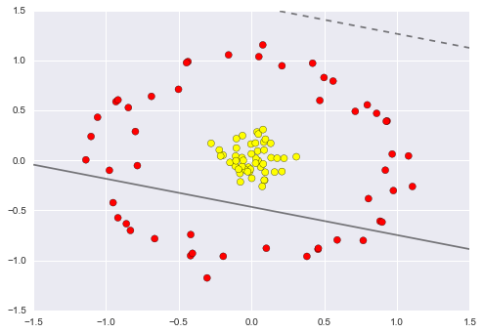

**In [12]**

r = np.exp(-(X ** 2).sum(1))

**In [13]**

from mpl_toolkits import mplot3d

def plot_3D(elev=30, azim=30, X=X, y=y):

ax = plt.subplot(projection='3d')

ax.scatter3D(X[:, 0], X[:, 1], r, c=y, s=50, cmap='autumn')

ax.view_init(elev=elev, azim=azim)

ax.set_xlabel('x')

ax.set_ylabel('y')

ax.set_zlabel('r')

interact(plot_3D, elev=[-90, 90], azip=(-180, 180),

X=fixed(X), y=fixed(y));

